**University of Michigan – Dearborn**

**Department of Computer and Information Science**

**CIS 150L – Fall 2014**

Lab 10

Srinivas Simhan

11/17/14

**Table of Content**

1. Question 1 3
   1. Screenshot 3
   2. Source Code 3
2. Question 2 6
   1. UML Class Diagram 6
3. **Question 1**
   1. **Screenshot**

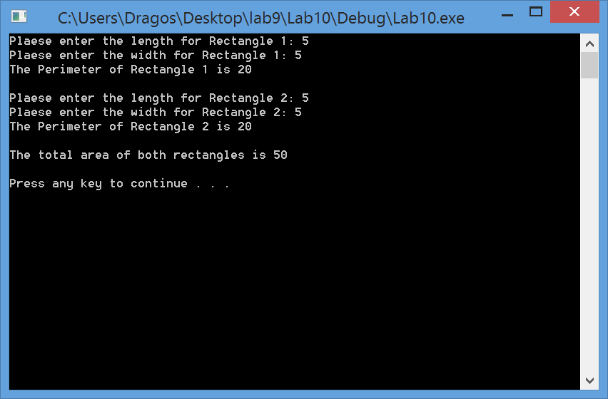

* 1. **Source Code**
     1. **Header File:**

//Purpose: Header File for Rectangle Class

//Author: Srinivas Simhan

//Date Created: 11/17/14

//Date Modified: 11/17/14

#ifndef RECTANGLE_H

#define RECTANGLE_H

class Rectangle

{

private:

float length; //length of the rectangle

float width; //width of the rectangle

public:

//the get and set functions

float getLength();

void setLength(float);

float getWidth();

void setWidth(float);

//functions to compute area and perimeter

float computeArea();

float computePerimeter();

};

#endif;

* + 1. **Implementation File:**

//Purpose: Implementation File for Rectangle Class

//Author: Srinivas Simhan

//Date Created: 11/17/14

//Date Modified: 11/17/14

#include "Lab10Q1.h"

using namespace std;

//Purpose: Get length

//Author: Srinivas Simhan

//Date Created: 11/17/14

//Date Modified: 11/17/14

float Rectangle::getLength()

{

return length;

}

//Purpose: Set Length

//Author: Srinivas Simhan

//Date Created: 11/17/14

//Date Modified: 11/17/14

void Rectangle::setLength(float v)

{

length = v;

}

//Purpose: Get width

//Author: Srinivas Simhan

//Date Created: 11/17/14

//Date Modified: 11/17/14

float Rectangle::getWidth()

{

return width;

}

//Purpose: Set width

//Author: Srinivas Simhan

//Date Created: 11/17/14

//Date Modified: 11/17/14

void Rectangle::setWidth(float v)

{

width = v;

}

//Purpose: Compute the Area

//Author: Srinivas Simhan

//Date Created: 11/17/14

//Date Modified: 11/17/14

float Rectangle::computeArea()

{

float area;

area = length * width;

return area;

}

//Purpose: Compute the Perimeter

//Author: Srinivas Simhan

//Date Created: 11/17/14

//Date Modified: 11/17/14

float Rectangle::computePerimeter()

{

float perimeter;

perimeter = (2 * (length + width));

return perimeter;

}

* + 1. **Source File (Main):**

//Purpose: Main Source Code File for Rectangle Class

//Author: Srinivas Simhan

//Date Created: 11/17/14

//Date Modified: 11/17/14

#include "Lab10Q1.h"

#include <iostream>

using namespace std;

int main()

{

float l1, w1; //length and width of rectangle 1

float l2, w2; //length and width of rectangle 2

float p1, p2; //perimeter of rectangle 1 and 2

float a1, a2; //area of rectangle 1 and 2

float totalArea; //Total Area of both rectangles 1 and 2

Rectangle r1, r2;

//Rectangle 1

cout << "Plaese enter the length for Rectangle 1: ";

cin >> l1;

r1.setLength(l1);

cout << "Plaese enter the width for Rectangle 1: ";

cin >> w1;

r1.setWidth(w1);

p1 = r1.computePerimeter();

cout << "The Perimeter of Rectangle 1 is " << p1 << endl <<endl;

a1 = r1.computeArea();

//Rectangle 2

cout << "Plaese enter the length for Rectangle 2: ";

cin >> l2;

r2.setLength(l2);

cout << "Plaese enter the width for Rectangle 2: ";

cin >> w2;

r2.setWidth(w2);

p2 = r2.computePerimeter();

cout << "The Perimeter of Rectangle 2 is " << p2 << endl << endl;

a2 = r2.computeArea();

totalArea = a1 + a2;

cout << "The total area of both rectangles is " << totalArea << endl << endl;

system("pause");

return 0;

}

1. **Question 2**
   1. **UML Class Diagram**

